DS 522 Data Acquisition and Analytics
HOS06Ab1 Cleaning and Prepping Data with PBI
8/20/2022 Revised by Catherine Ata
05/06/2025 Reviewed by Naveena Moddu
10/21/2025 Reviewed by Ashwin Paturi
04/30/2026 Reviewed by Vishal Krishna Kumar
School of Technology & Computing (STC) @ City University of Seattle (CityU)


Before You Start
- Version numbers may not match the most current version at the time of writing. If given the option between a stable release (long-term support) and the latest version, please choose the stable release rather than the beta.
- This tutorial targets Windows users and macOS users.
- There might be subtle discrepancies along the steps. Please use your best judgment as you go through this cookbook-style tutorial to complete each step.
- For your working directory, use your course number. This tutorial may use a different course number as an example.
- The directory path shown in screenshots may be different from yours.
- If you are not sure what to do or are confused about any steps:
  - Consult the resources listed below.
  - If you cannot solve the problem after a few tries, ask a TA for help.

Key Concepts
- Power BI (Business Intelligence) Power BI is a powerful Data Visualization and Business Analytics tool provided by Microsoft. It helps us to provide interactive visualizations, dashboards, and BI reports with self-service capabilities. It is part of Microsoft Power Platform.
- Power BI Desktop is a free application you install on your local computer that lets you connect to, transform, and visualize your data. With a Power BI Desktop, you can connect to multiple data sources and combine them (often called modeling) into a data model. This data model lets you build visuals and collections of visuals you can share as reports with other people inside your organization. Most users working on business intelligence projects use Power BI Desktop to create reports and then share them in the Power BI service.

Learning Outcomes
- Import data.
- Transform data.
- Appending and shaping data.

References
- Power BI Docs. (2024). What is Power BI? Power BI Docs. https://powerbidocs.com/2019/11/28/what-is-power-bi/
- Power BI Docs. (2024). What is Power BI Desktop? Power BI Docs. https://learn.microsoft.com/en-us/power-bi/fundamentals/desktop-what-is-desktop

STEP 1: Import data.
Open your Power BI Desktop app, close the initial startup window, and go to ‘Get data’ as shown below.

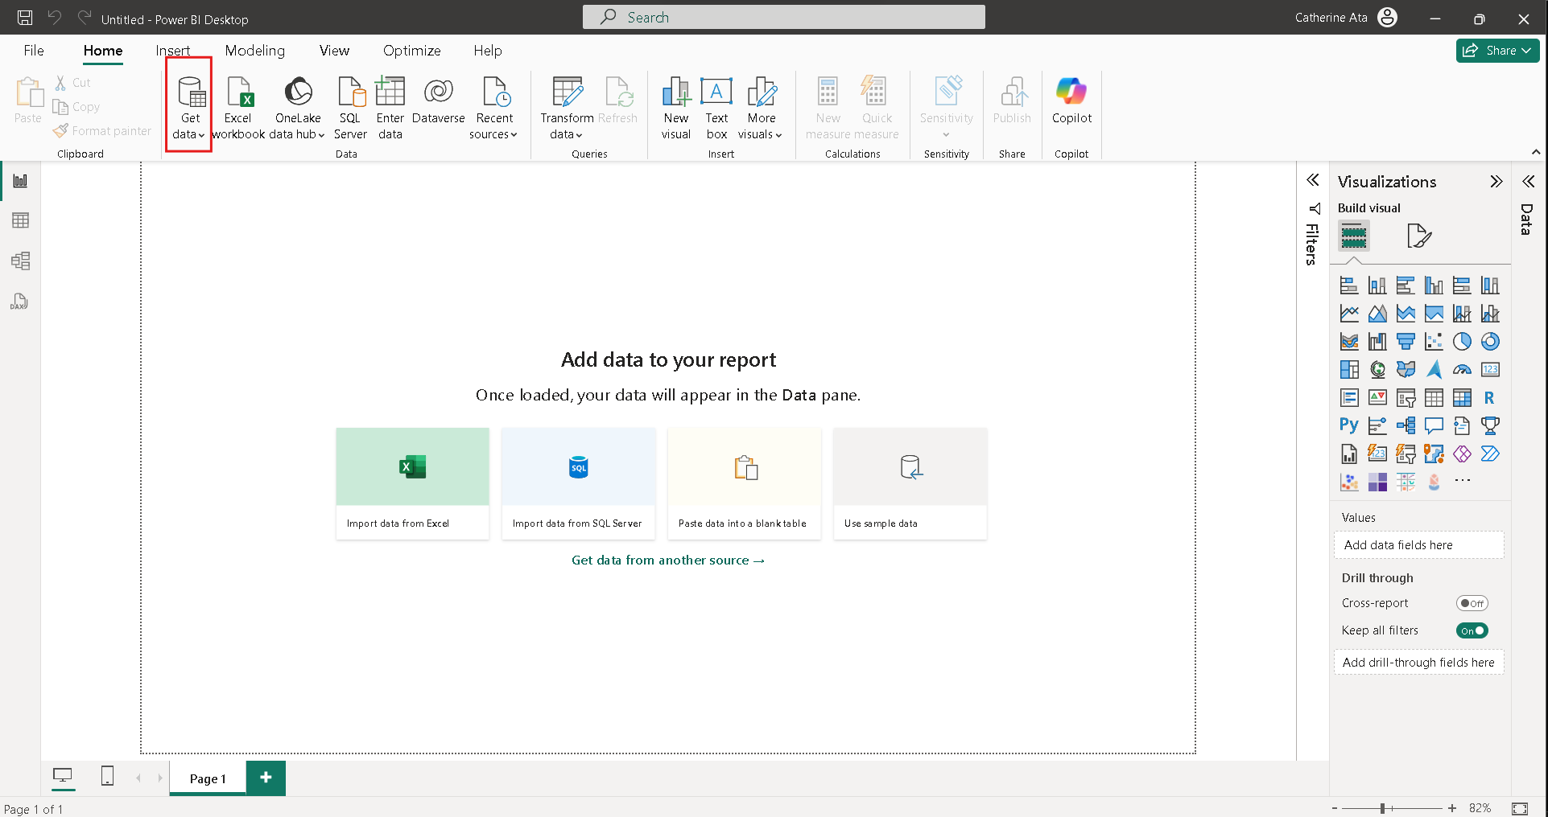

Among the list of options, click Text/CSV. Navigate to the FlightPerformance_2012_12.csv file provided with this assignment and open it.

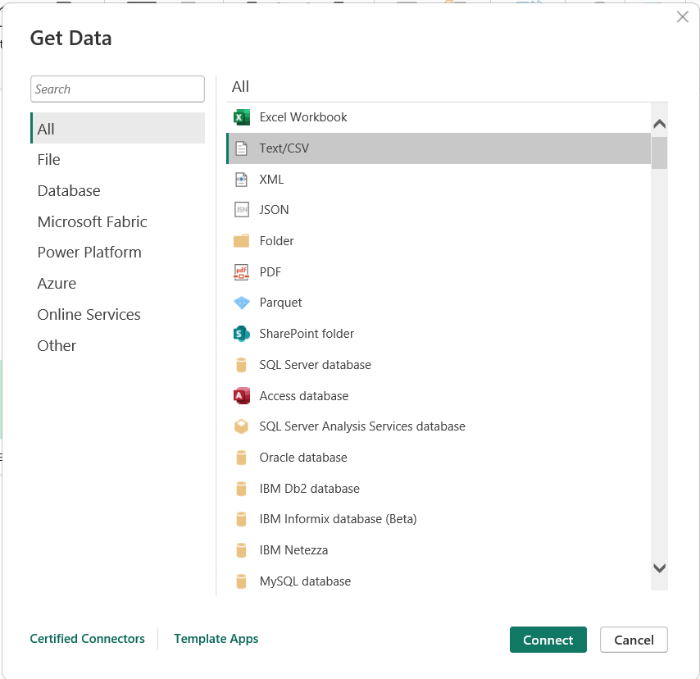

This will give you a preview of your table. At the bottom of the window, click Transform Data.

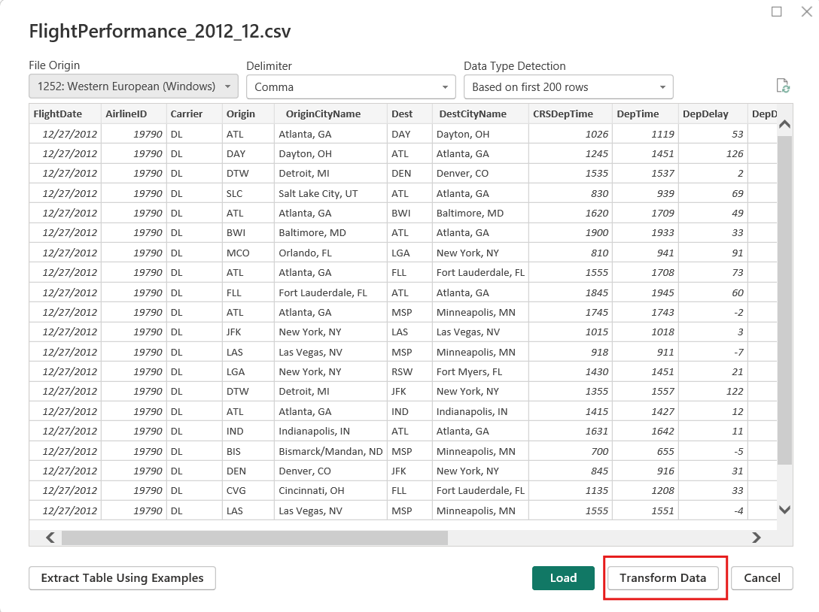

This will take you the Power Query Editor.
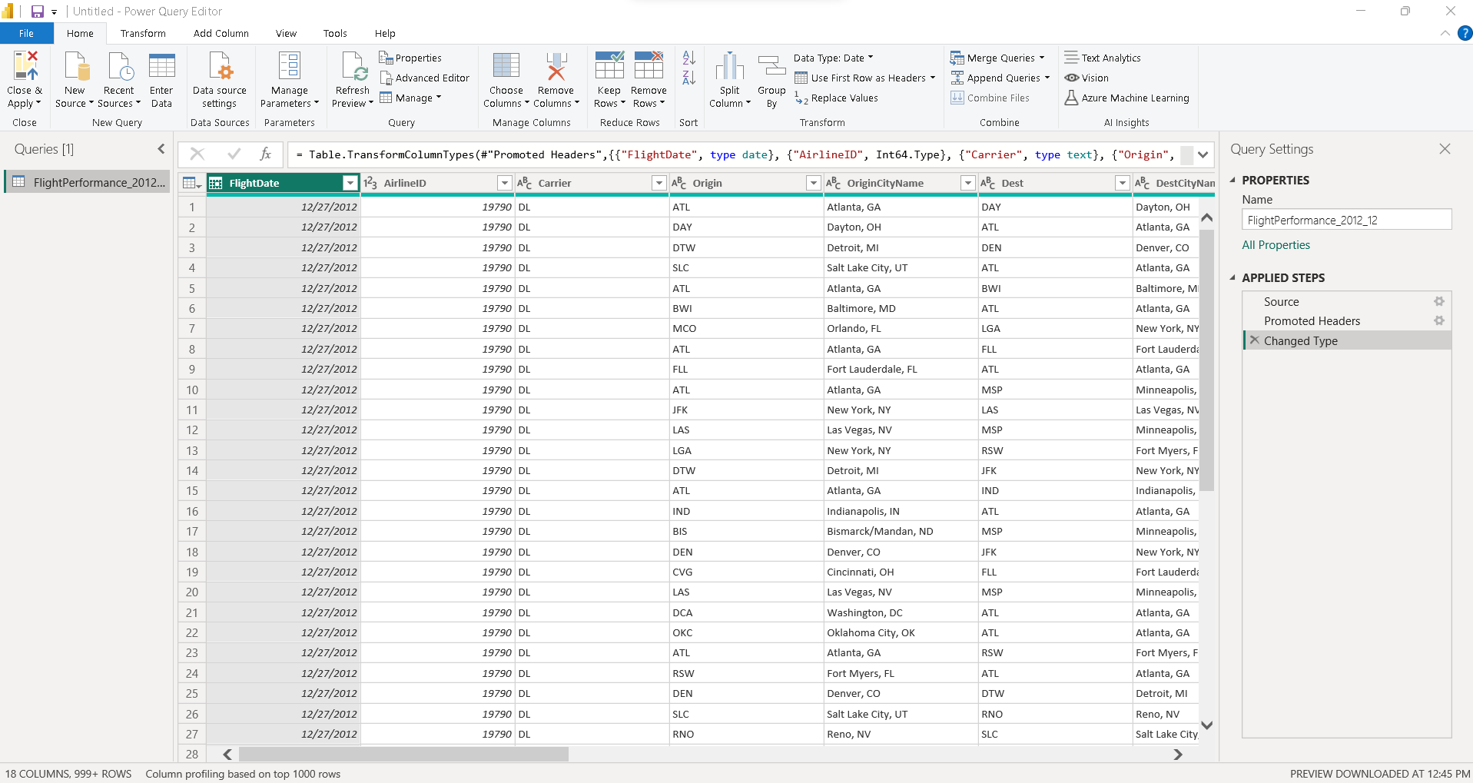

Under Query Settings at the right side of the Power Query Editor, change the name of the table to ‘FlightDelays.’
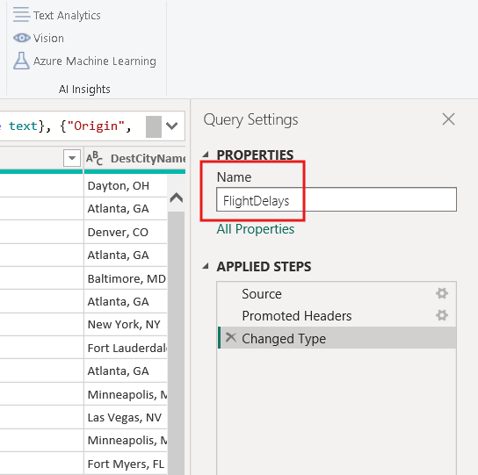

At this point, make sure all the columns are loaded under the correct datatypes; for example, the FlightDate column should be a ‘Date’ datatype. To make sure it is the correct datatype, highlight the column and under ‘Transform’ menu go to ‘Data Type’ and select Date as the type.

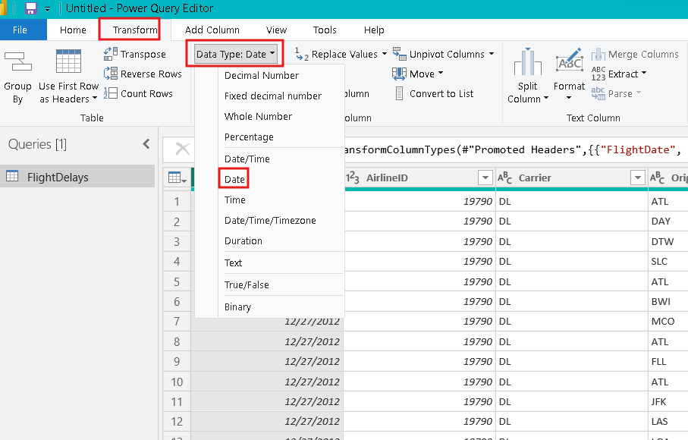

Checking the data type is the first step in data analysis, because only by ensuring the data type is correct can the analysis tools function properly.
When the datatypes are all correct, let us go back to the Home menu and select the ‘Choose Columns’ option.
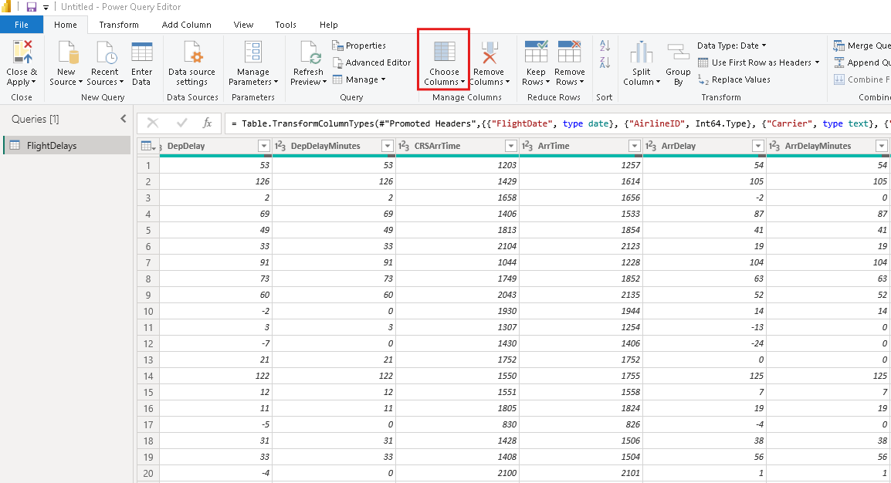

In the choose columns window, unselect everything and select the columns as shown below, and hit Ok.
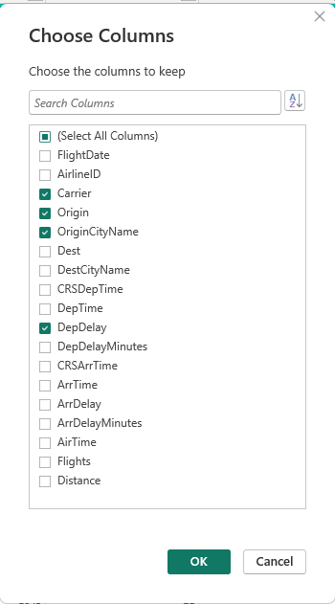
Under the dropdown menu for the DepDelay column, select ‘Number Filters,’ then the ‘Greater Than’ option.
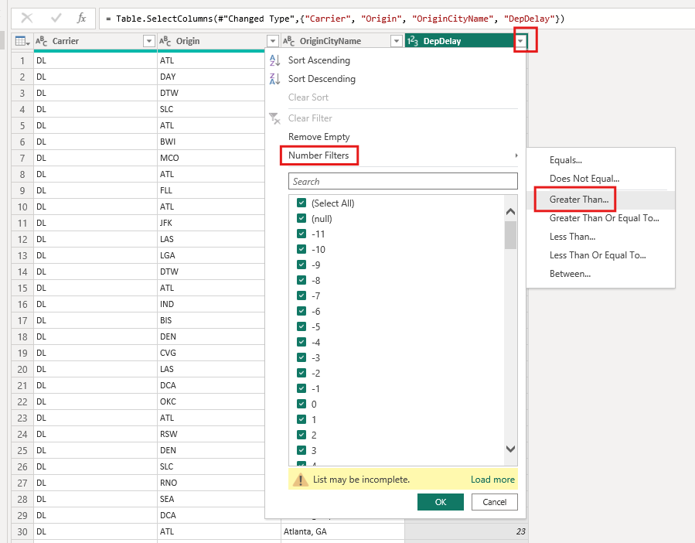

In this example, we want to filter out delays that are more than 15 hours. In the dropdown box, enter 15 as shown in the screenshot below, then hit OK.

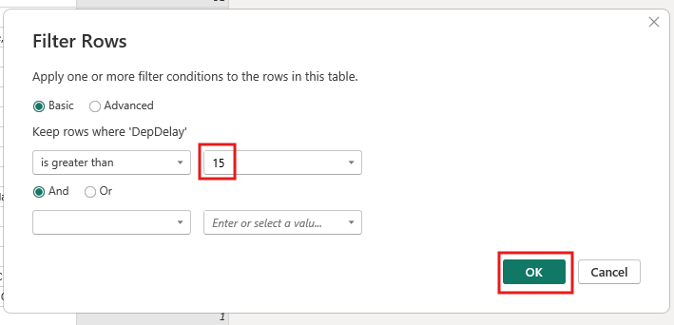
Your data for the FlightDelays table is ready.
Please take a screenshot of this table in the Power Query editor.

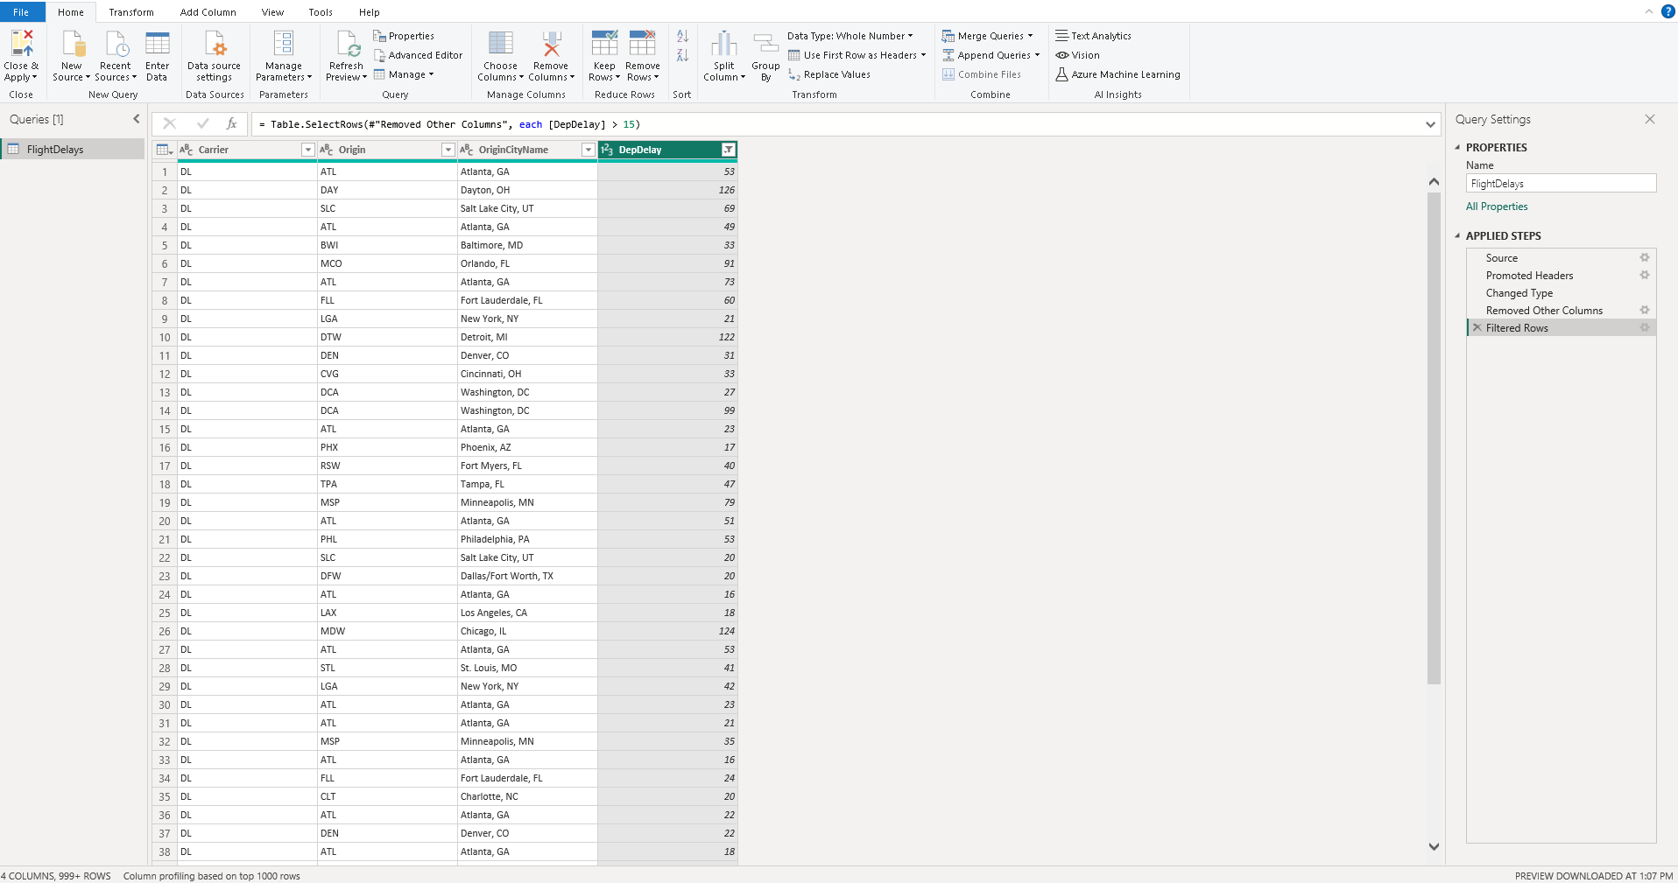

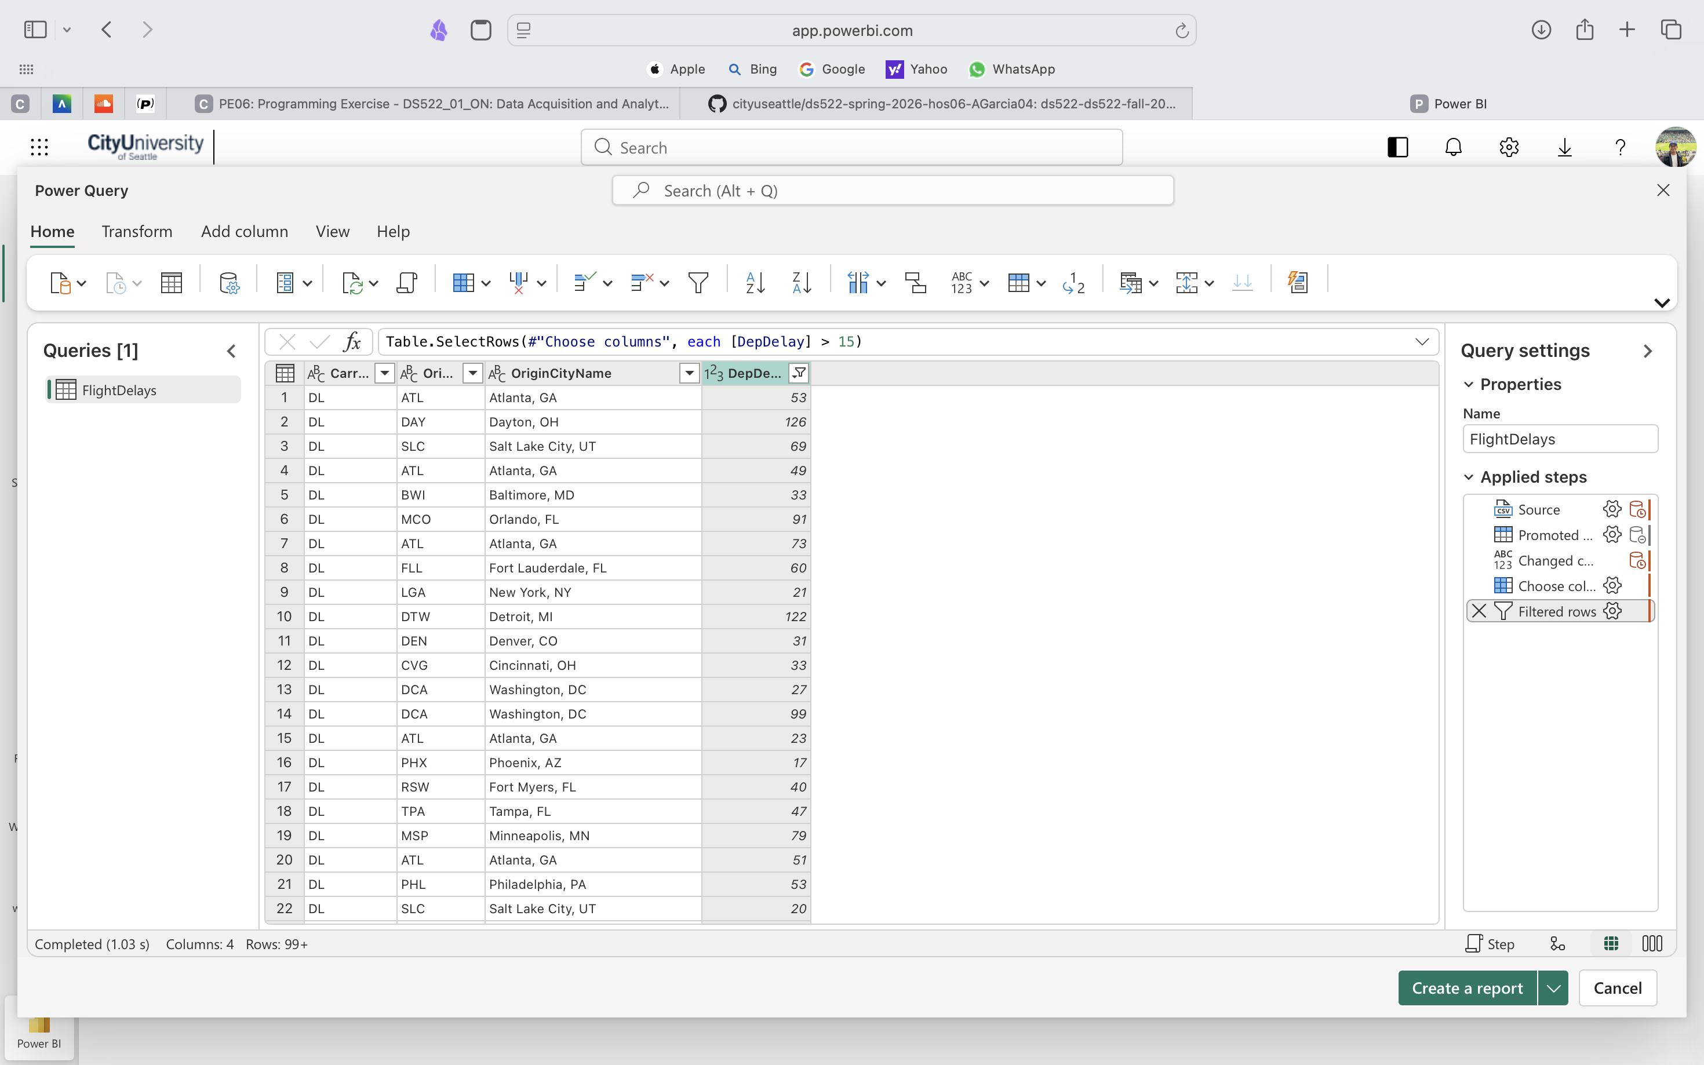
STEP 2: Appending and Shaping Data
To add data for another table, use the file FlightPerformance_2012_11.csv provided in the assignment. To do this, follow the instructions from STEP 1 through changing datatypes, and rename the new table to FlightDelays2.

Your data should look like this at this point.
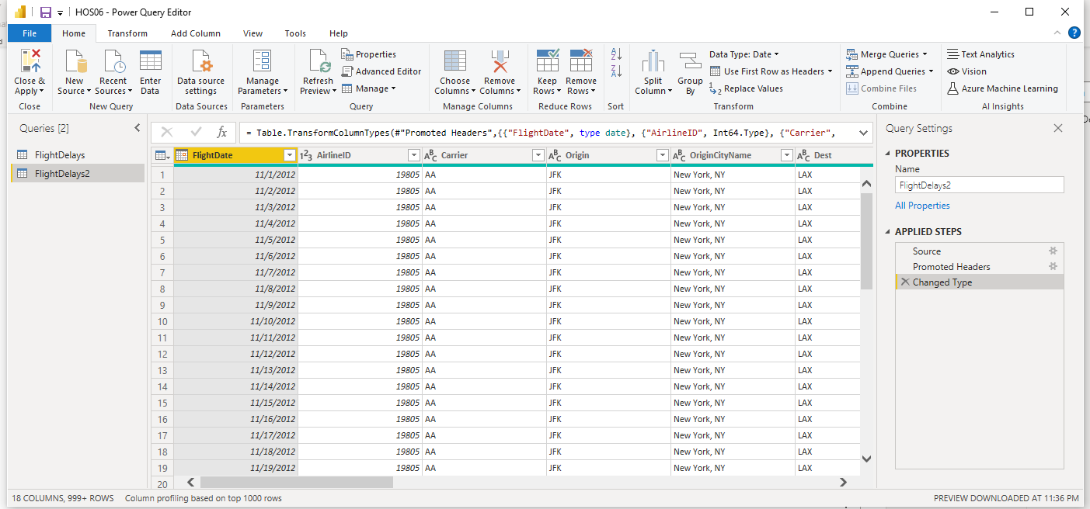

Now, right-click on the FlightDelays2 table and uncheck ‘Enable Load’.
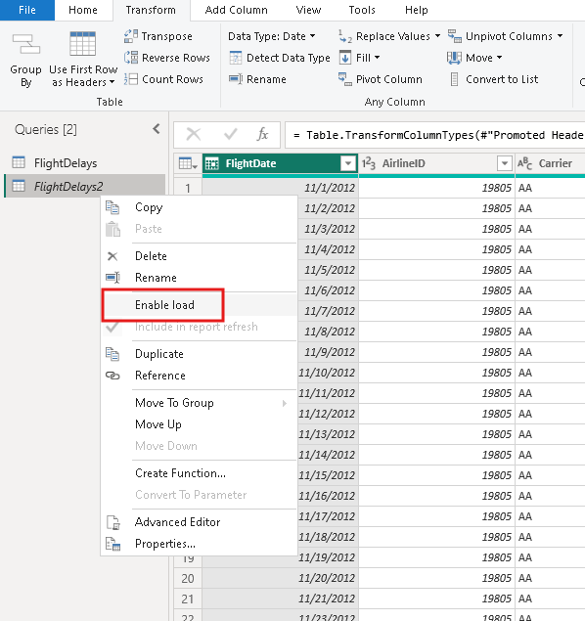

Now select the FlightDelays table and go to ‘Append Queries’ as shown below.
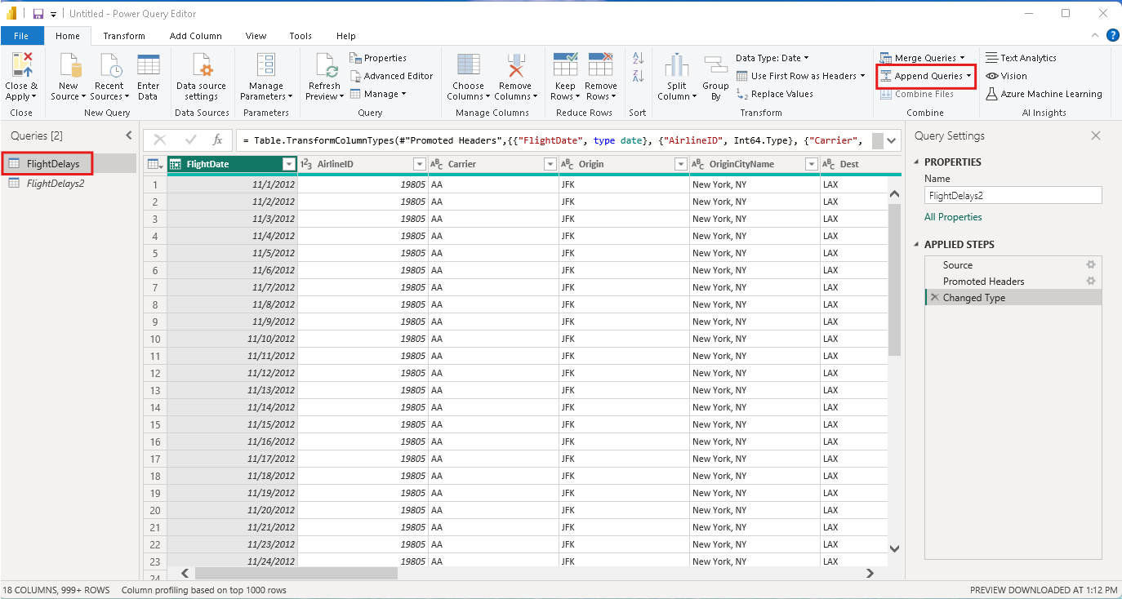

Select FlightDelays2 to append to and hit OK.

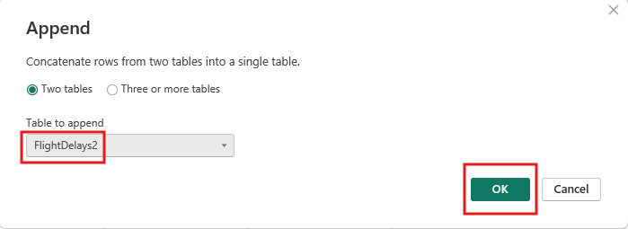

At this point, you can see that OriginCityName contains both City and State. We can split that column into two columns.
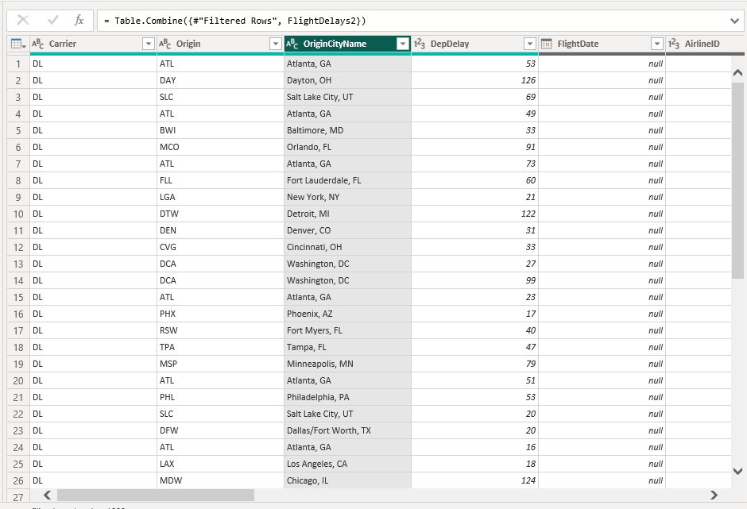

Select the ‘Split Column’ and select ‘By Delimiter.’

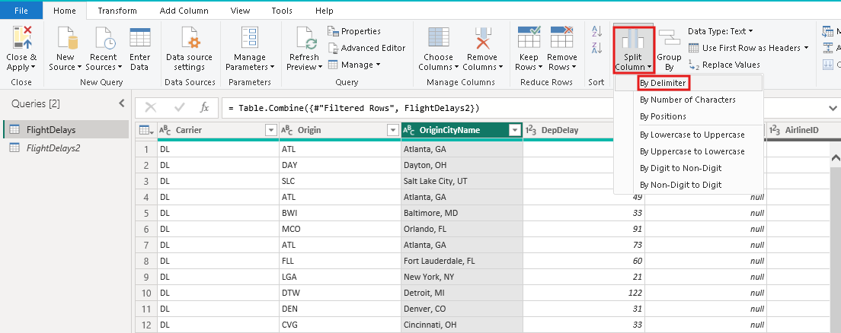

Make sure all the following options are checked in this window, then hit OK.
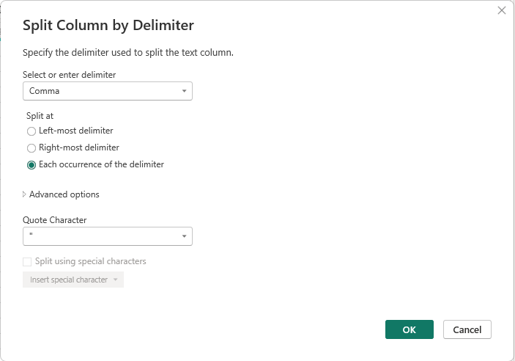

You can see that the column is now split into two columns.

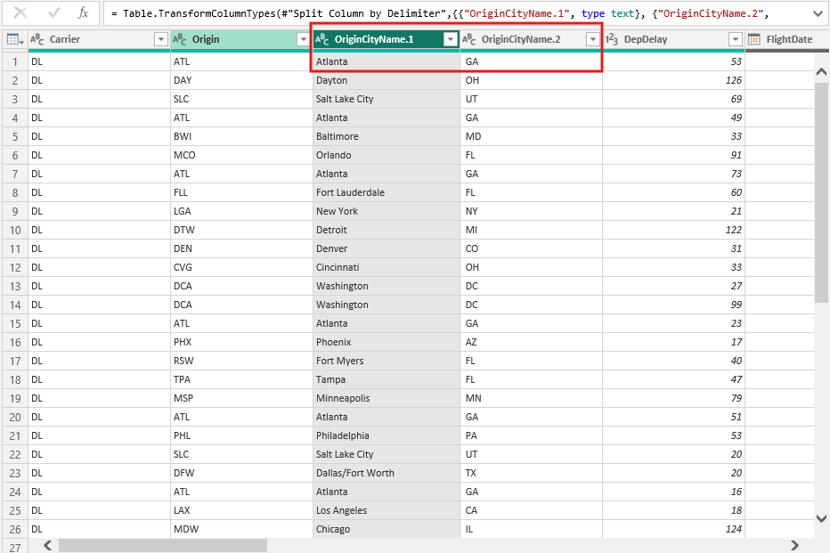
You can rename each of these columns by double-clicking on the column header and typing the new name.

You can rename them as OriginCity and OriginState.
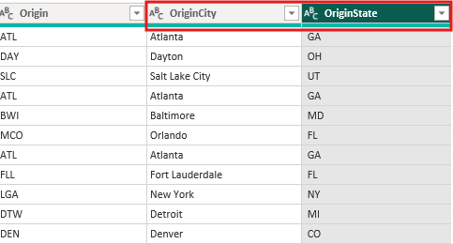
Let us learn one more trick here to replace values in a column.

Right-click on the OriginCity column and select ‘Replace Values’ as shown below.
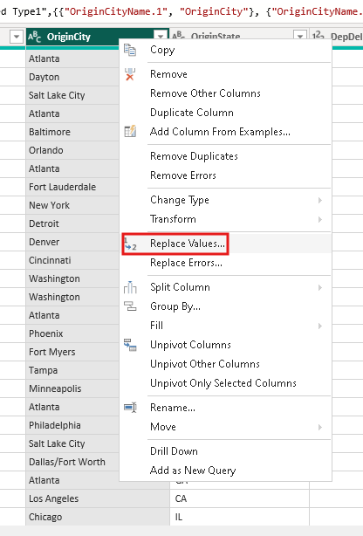
Type as below in each field and hit OK.

This way, you replace all occurrences of West Palm Beach/Palm Beach with Palm Beach.
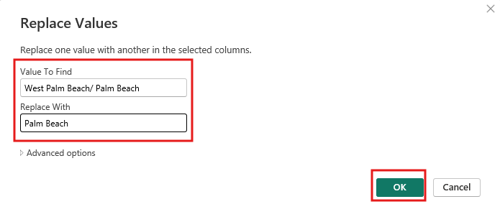
Take a screenshot of your Power Query Editor window, like below. Make sure to include the Query Settings bar on the right.

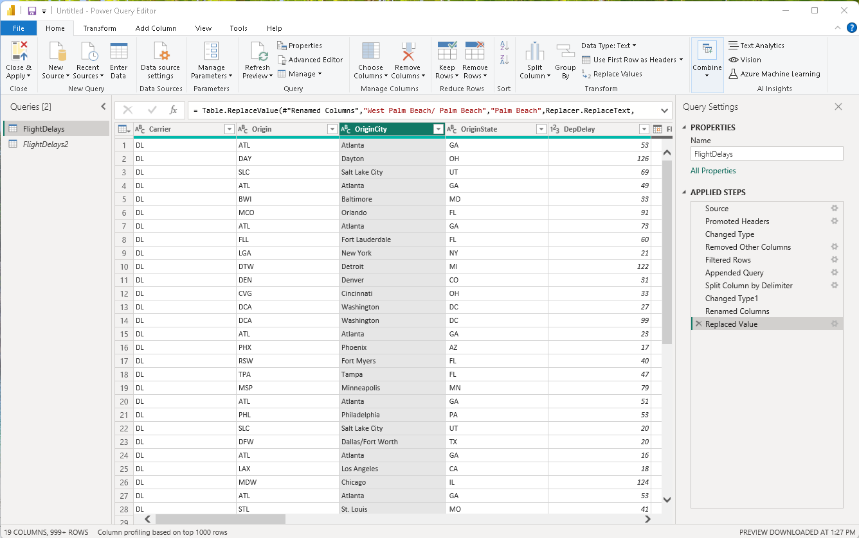
Save all your screenshots to the Submission file.
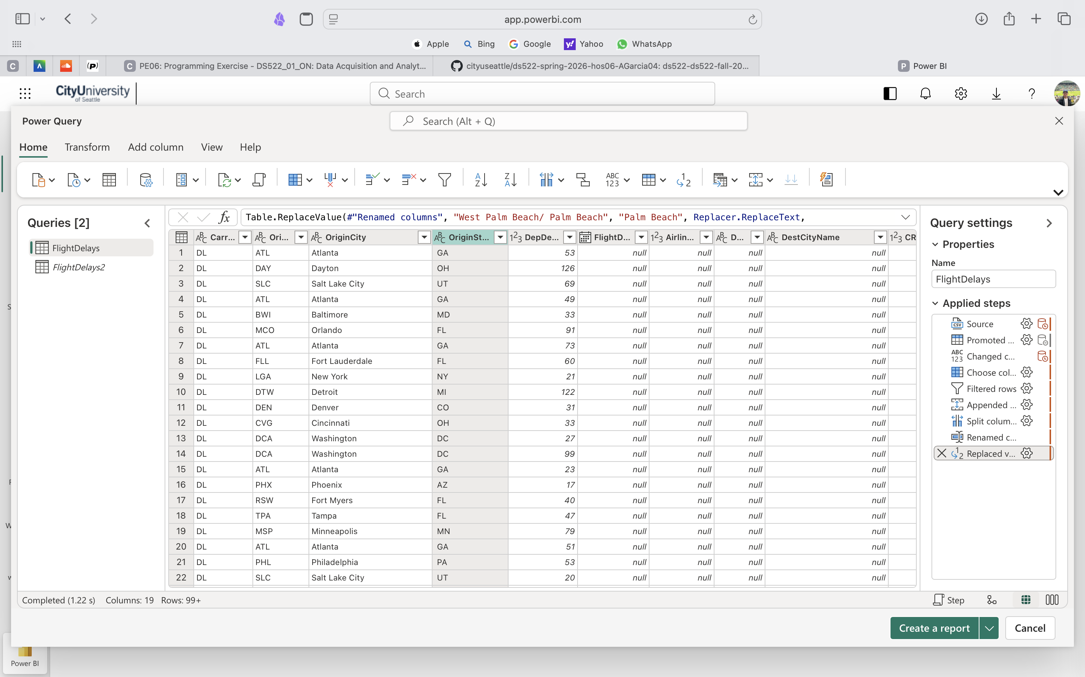

Push your work to GitHub.
Include your screenshots stored in this file: HOS06A- 3 – Name_ Submission.pdf
Follow the instructions on the CityU STC TA Center Github.io Submit your work page.

